# Light & Shadows

A scientific look into Oil Painting

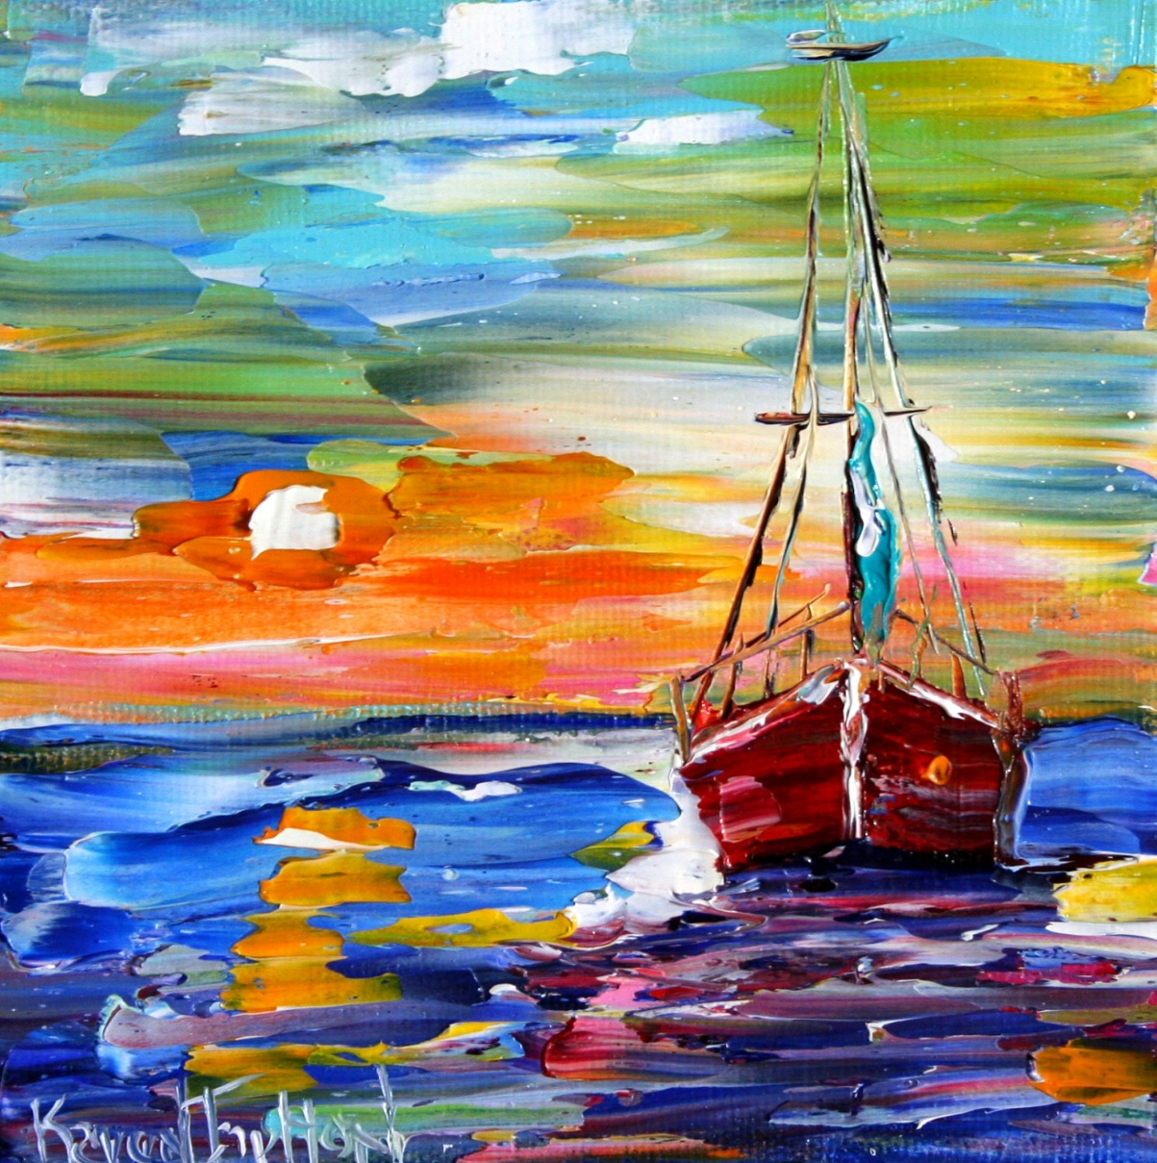

Ana Clara Rios Gouveia

Boston, MA, USA

January 26, 2018

Contents

Light & Shadows 1

This sounds like Physics: 5

[GEOMETRY & What’s up in the Universe] 5

Questioning Light & Heat? 7

What is light? 8

8

Sources of Light: 8

8

How light diffuses through different mediums: 8

From white light to a rainbow – prism: 9

9

From a spectrum of light to a series of colorful waves: 9

How these waves behave: 10

What did Einstein say about relativity? 10

So… What is Color? 10

And How does the 7-color spectrum form a sonic world too? 11

Beyond Colors: 11

Art Concepts 12

Perspective, Reflexes & Tones: 12

Geometry: 14

House Elevations & Side Sections: 14

Structures: 14

Exercise – Find and Glue below Plans, Elevations, 3-D Views, Sections or Any Images That You Appreciate: 15

Materials & Textures: 16

Dynamics & Movement: 17

Exercise - Find and glue below two different pictures that show dynamic & movement: 17

Painting Layers 18

Defining Boundaries 18

Understanding Quantities & Ratios (Perpendicular) (Parallel) (Slopes) 18

Visualizing In Between The Lines [Two sketches errors] 18

Painting in Engineering & Architecture: (Plan) (Elevation) (Section) (Details) 18

Painting 19

From having a designated area to paint, to using your creativity to set up the materials needed to paint, the photo below shows my current art set-up as a suggestion: 19

Going from lines to backgrounds: 19

Mixing colors - Always keep a good balance: black – colors – white; 20

Transparency & Glows: 21

Mists & Smokes: 21

Same as a chimney smoke, or water mist… it is somewhat of the same color, no? 21

Fine line Details: 21

Up Keep & Materials Maintenance: 22

Once you have the following materials staged you are ready to start: 22

⇨ Paint + Palette + Brushes + Containers w/ Solvents + Rags + Easel(canvas) 22

⇨ <Amazon Oil Painting Material List> (http://www.amazon.com/hz/wishlist/ls/SUECQDK8X4YK) 22

Paint 22

Palette – Wood vs. Plastic vs. Styrofoam: (A little math exercise) 22

Brushes 22

Maintenance: 23

So what do you think are best practices to keep your oil painting supplies longer? _______________________. 23

Cleaning up the Palette + Brushes + Containers + Rags 23

Chemistry of Oil Paint: 23

<Where you can check this info: Google> 23

Cleaning up materials chemistry: 23

QUESTIONS: 24

How do solvents and oil bond? _________________________________________________________. 24

What mixture do you think will best clean up your brushes, palette & containers? _________________. Why would you think so? ______________________________________________________________. 24

What kind of moods do the following paintings allow you to feel? 24

# This sounds like Physics:

This is a collection of stories I once heard:

## [GEOMETRY & What’s up in the Universe]

For many year man questioned how does all around us exist?

They thought, first there must be a universe.

How does it look like… we don’t know.

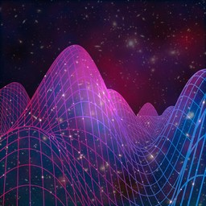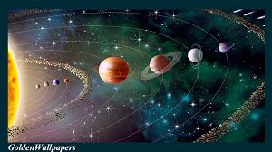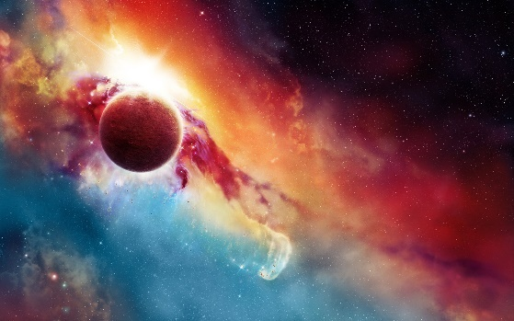

#### <Universe Photos>

But in our system, and our main guide is the Sun, that shall be our mother coordinate.

It is our source of heat and light, and without it, much of our experience would never be a word.

It shines from up above, and through its white light we are allowed to see all that surround us.

#### <Solar System Photos>

Scientists before us have told stories about the nature of light waves, how they travel from their source through a medium, assumed as vacuum for some reason, to the point where it reaches us.

#### <Sun Light Travel Photos>

As weird as it all sounds, it still works. And we collectively experience a reality where all this science capture the world around us and transform into something real.

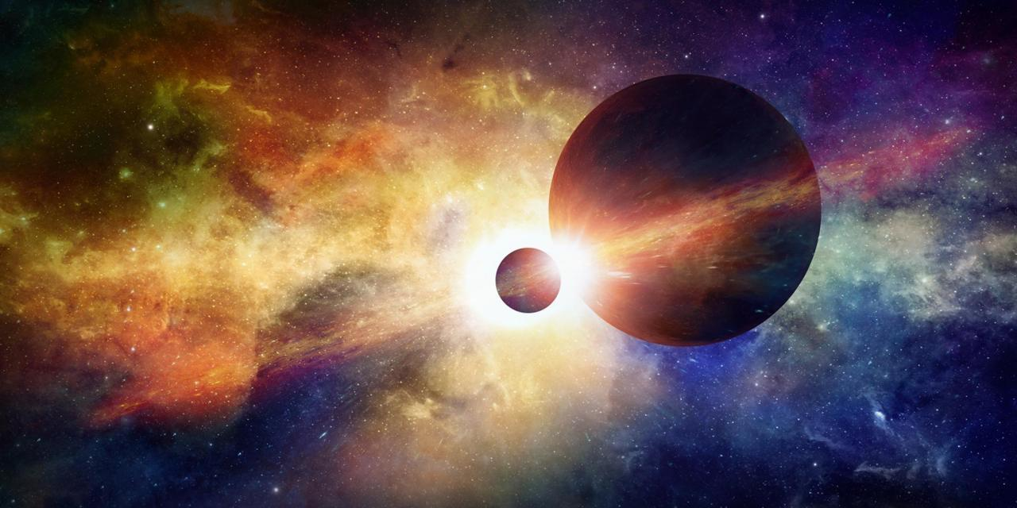So… the sunlight bounces on the moon, and it reflects on the earth, and for whichever reason that light exists when we are turning around some axis, that is somewhat defined by a global system of coordinates.

#### <Global Maps>

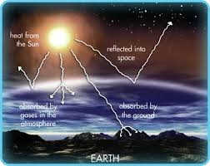And that’s just what happens in the Earth. Which is blue and green. But around here, the other planets are a bit different, for whatever materials they have there, and for whatever reason for which they exist at the distance that it orbits this 8-planet solar system.

(I will forever miss Pluto and the idea of how cold it is right outside that cone.)

Then there were some thoughts that it had to do with the forces of attraction between the physical and electric fields (not to mention magnetics) between two bodies, and through that law, we’ve continued to design our existing world.

## Questioning Light & Heat?

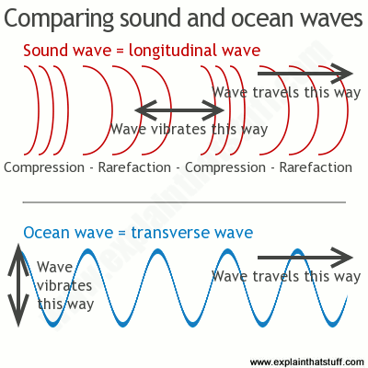A long time ago, a boy named Albert questioned his professor proposition.

That story has been published on YouTube [Got existiere – Einstein, A.]

(https://www.youtube.com/watch?v=8O_NV7gtzoQ)

In it, Einstein speaks of two poles: Heat, Warmth, White Light, exists. Cold, Darkness, does not. In the fight between dark and light, it is only through light that we are able to see the world around us.

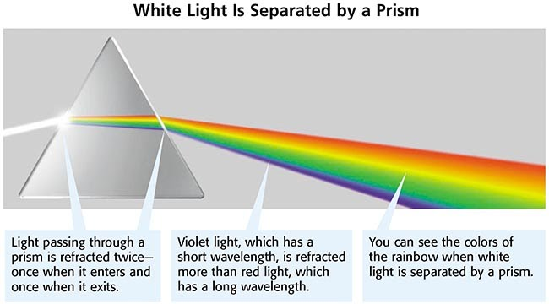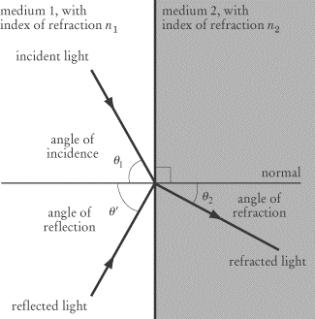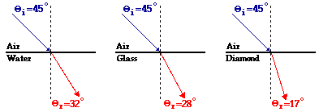Therefore, understanding the physics behind it, will allow you to better understand the medium with which we work with and that we try to express through our art.

# What is light?

## 

## Sources of Light:

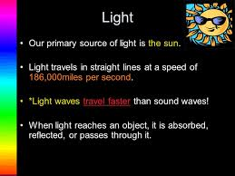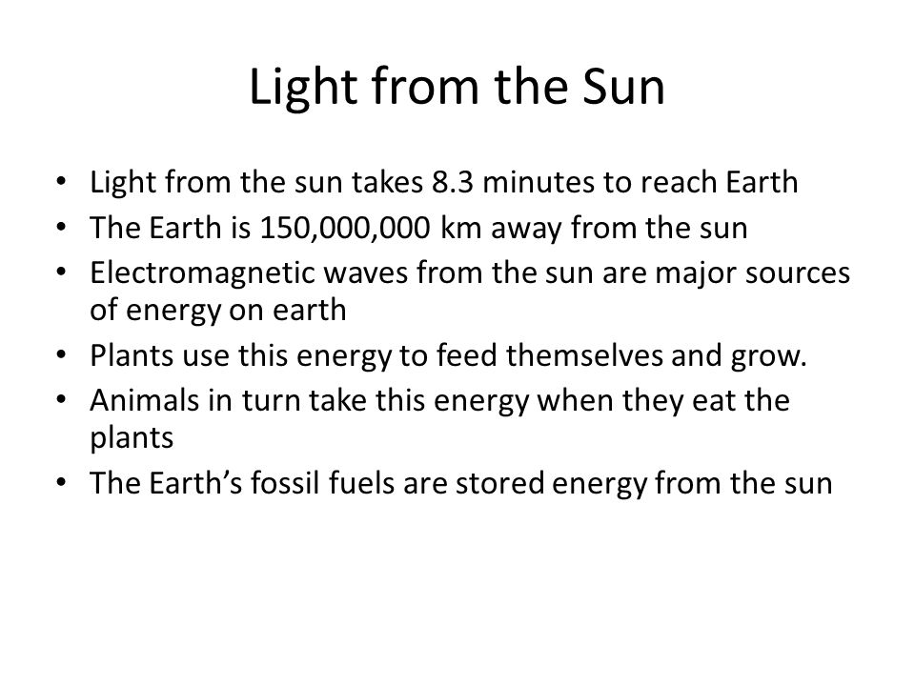

#### <2-lights & 1 shadow>

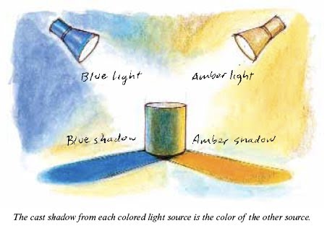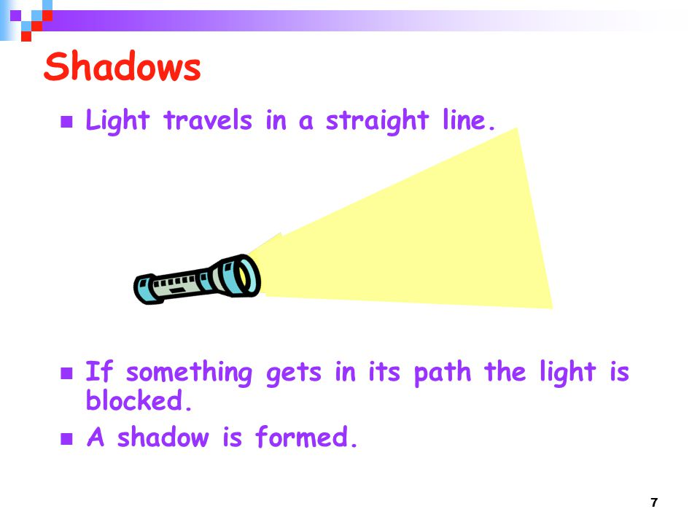

## 

## How light diffuses through different mediums:

Based on densities… and other properties. But light works more or less like this:

## From white light to a rainbow – prism:

## 

## From a spectrum of light to a series of colorful waves:

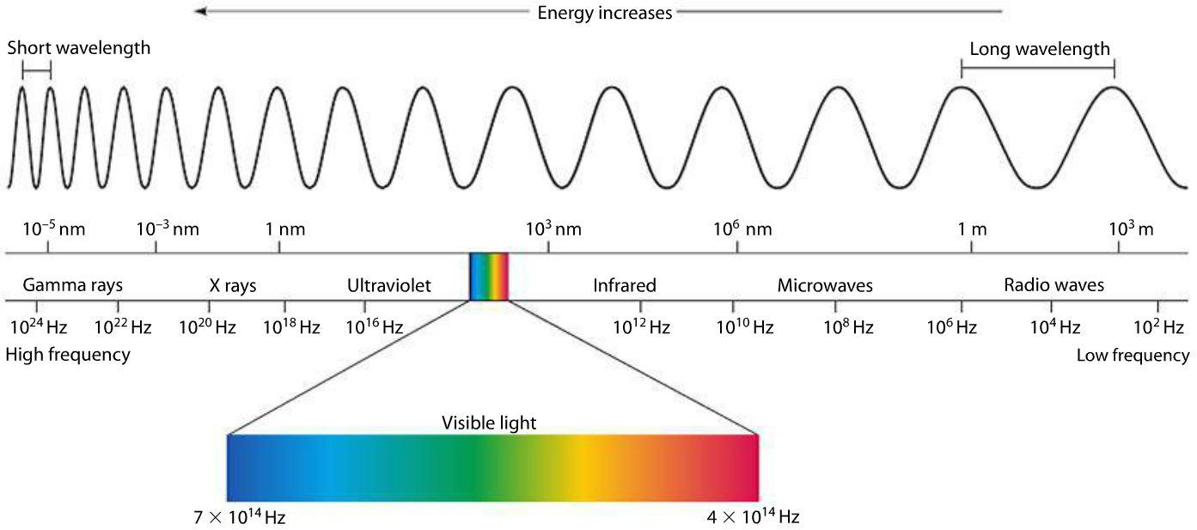

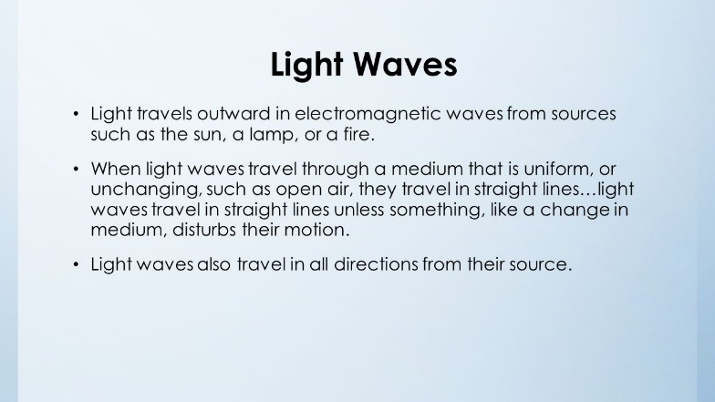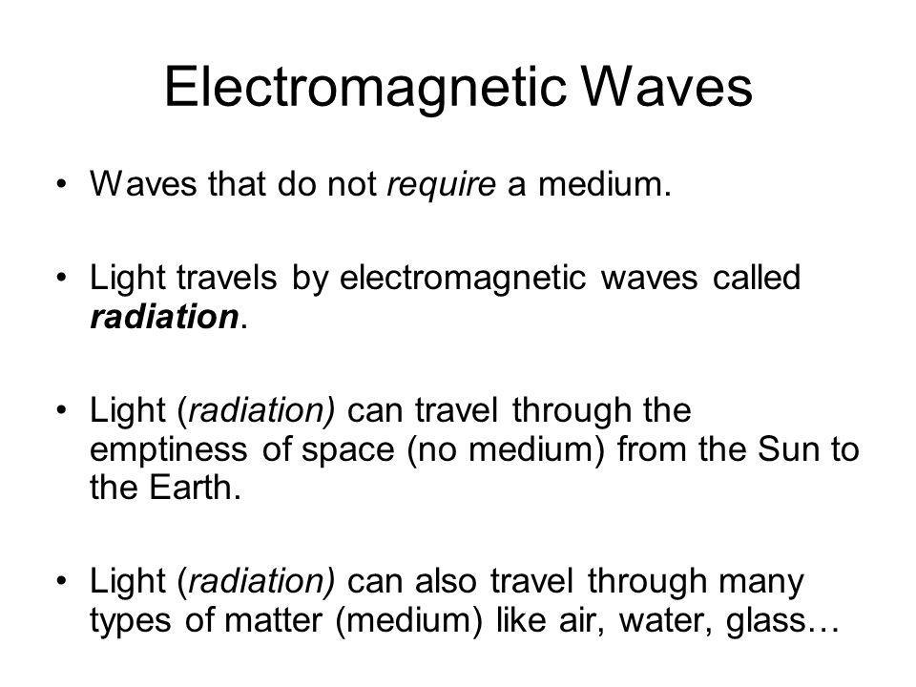

<Brain-waves & other waves in physics>

## How these waves behave:

#### <Between physics & mathematics>

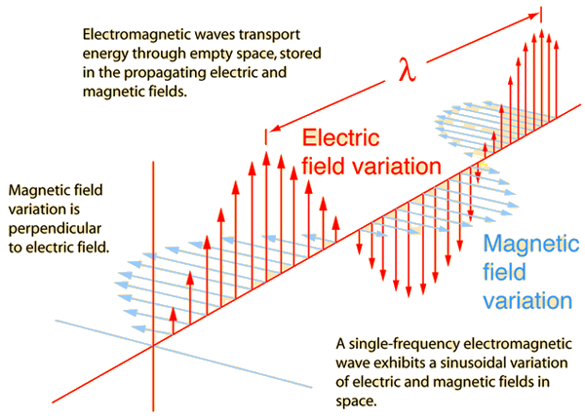

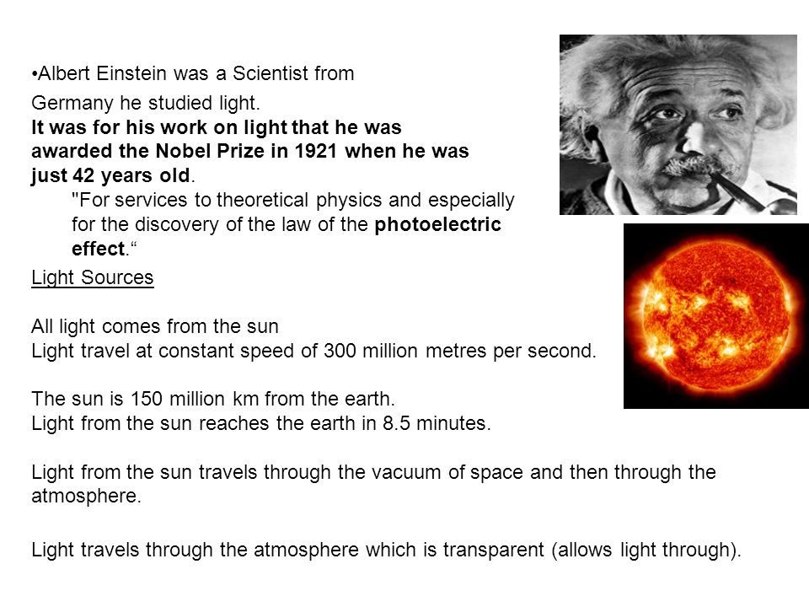

## What did Einstein say about relativity?

#### <Referential.m>

He probably said a lot more than just that, but that’s a whole different story.

But from the light up above, we get into world of colors… this is how:

## So… What is Color?

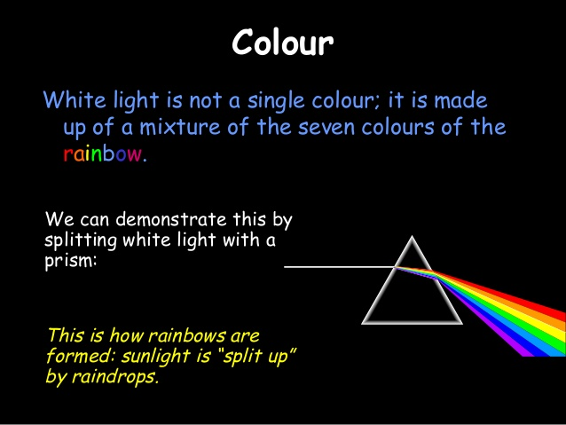

## And How does the 7-color spectrum form a sonic world too?

#### 

#### <TheMusicalNautilus.m>

([www.github.com/anagouveia1/matlab/README.MD](http://www.github.com/anagouveia1/matlab/README.MD))

# Beyond Colors:

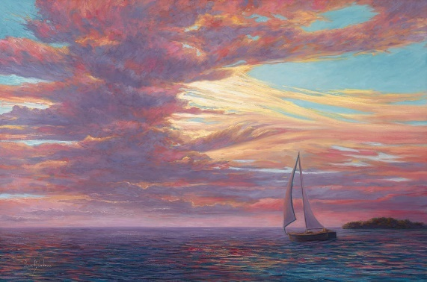In this planet, we observe things nearby us. The world we see has a blue sky, the grass is green, and those same principles from up above in the universe apply to this space. Not everywhere though, the world has many different landscapes to be drawn.

Where lines make up planes, the different levels in the one plane of the canvas, allows the observers to experience the reality the artist is trying to communicate.

The way these lines are drawn may keep a very well-structured reality, such as in an Architectural Drawing Set, or they may convey a unique world the artist sees.

Ideas can be utilized to stimulate the imagination and allow the young artist into developing its own creative thoughts into a piece of art.

# Art Concepts

The following topics are some of the concepts that are utilized through many artistic practices. The many figure included within topics are representations of the ideas transposed through the image’s material.

## Perspective, Reflexes & Tones:

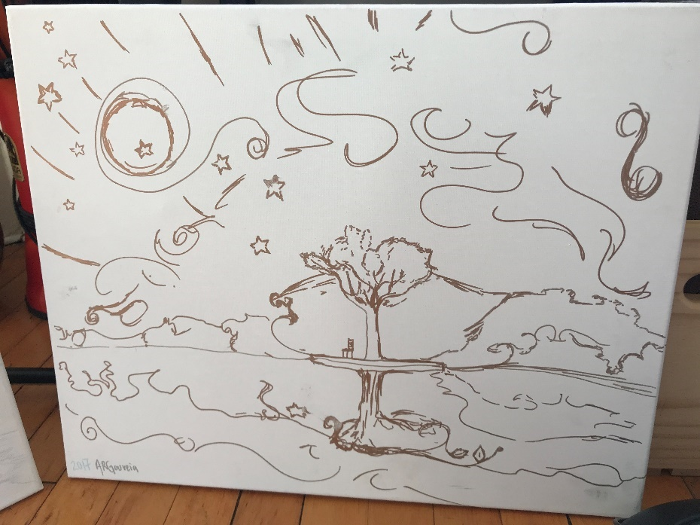***<Figure1: Golden World>***

What is wrong with Figure 1 photo? _________________________________________________________________.

Does this image give you a feeling of **warmth** or **coolness**? (Circle the emotion you feel through it)

***<Figure2: Silverly Lines>***

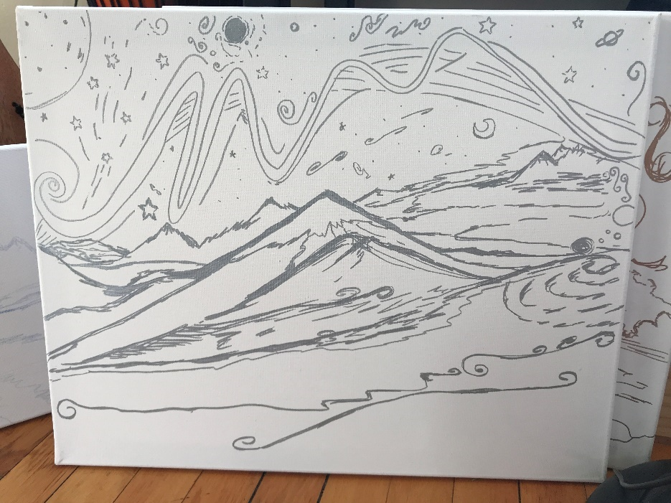

**What about this second figure, what type of feelings does it express?**

**________________________________________________________________________________________________.**

***<Figure 3: Allston Living Room> <Figure 4: Living Room on a Canvas>***

|  |  |
| --- | --- |
| **Reality** | **Canvas** |
| **Notes: ________________________________________**  **______________________________________________.** | ***Q.* Or what type of emotions it communicates/ express?**  **_____________________________________________.** |

**What type of art do you think each of the following drawings represent?**

|  |  |
| --- | --- |
|  |  |
|  |  |

**Possible Test Question Answers:**

<Figure 1> <Figure 2>| <Figure 3><Figure 4> | <Figure 5-8> | Warmth Cold Perspective & Reality 4imgs

## Geometry:

Lines, Planes, 3-D

Line Properties

Surface Areas & Engineering Plans, Elevations, Sections & Details.

|  |  |
| --- | --- |
| Image result for structural planHouse Plan: (Structural Framing Plan for Levels 1-N) | Image result for elevation planHouse Elevations & Side Sections: |

## Structures:

#### Bridges vs. Buildings

|  |  |  |
| --- | --- | --- |
| **DWG** | **Bridges** | **Buildings** |
| **Plan** | Top View | Different floors |
| **Elevation** | East & West | North & South |
| **Section** | North & South Approaches | East & West |
| **Details** | * | A connection |

## Exercise – Find and Glue below Plans, Elevations, 3-D Views, Sections or Any Images That You Appreciate:

## Materials & Textures:

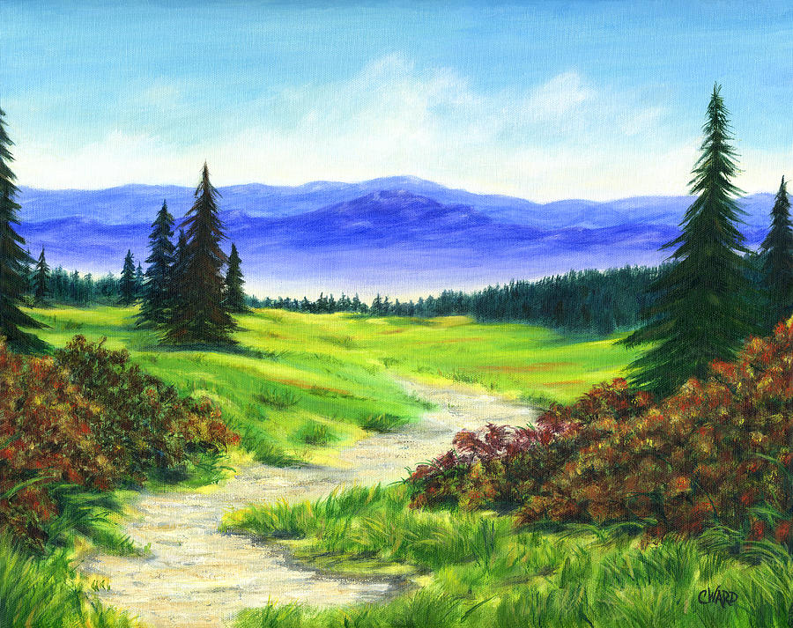Through the different boundaries multiple universe collide. Below a few examples of color boundaries.

#### Sand & Ocean:

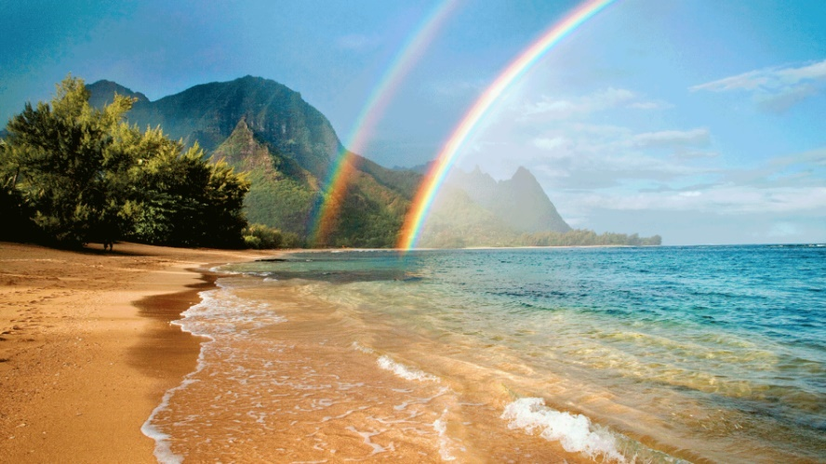Any other boundaries you notice here? ______________.

#### Mountain & Sky

#### River & Field:

#### 

#### Leaves, Flowers & Clouds… What other details do you think we could mention?

_____________________

_____________________

## Dynamics & Movement:

#### Where is the wind going? _________________________________________________________________________.

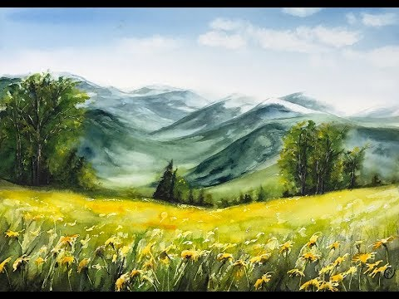

## Exercise - Find and glue below two different pictures that show dynamic & movement:

# Painting Layers

So how do we go about painting?

## Defining Boundaries

#### 

#### From idea to first sketch.

## Understanding Quantities & Ratios (Perpendicular) (Parallel) (Slopes)

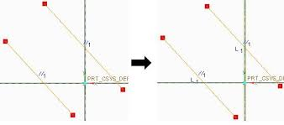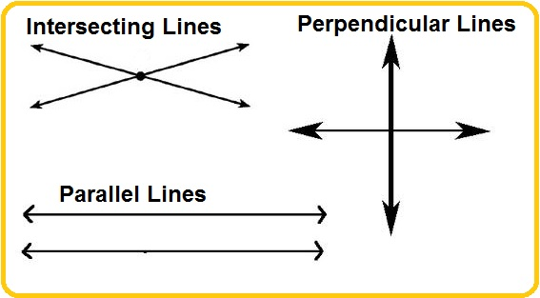

## Visualizing In Between The Lines [Two sketches errors]

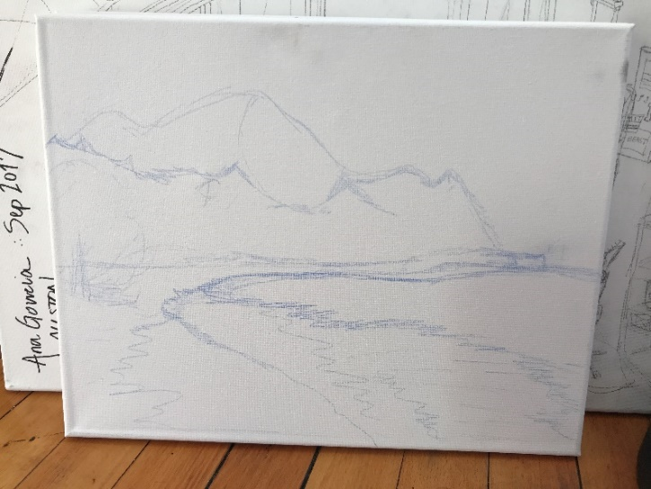Can you see the line sketch error? What is it? ________________________________________________________________________________________________.

## Painting in Engineering & Architecture: (Plan) (Elevation) (Section) (Details)

Concepts Overviewed: (Top-Down) (Heights & Levels) (Cuts & Planes) (3-D) (Dynamics) (Wind)

Questions? ______________________________________________________________________________________.

# Painting

### From having a designated area to paint, to using your creativity to set up the materials needed to paint, the photo below shows my current art set-up as a suggestion:

### Going from lines to backgrounds:

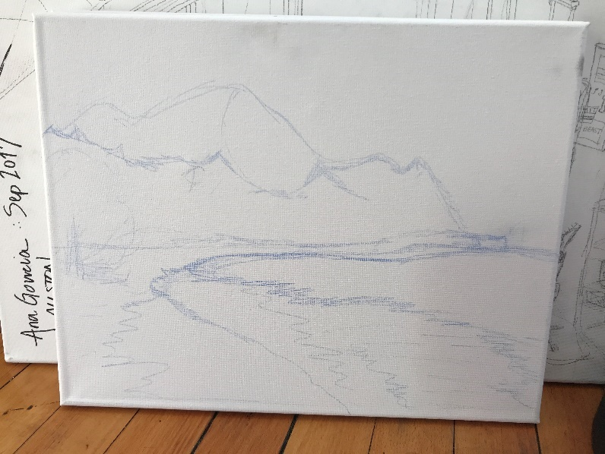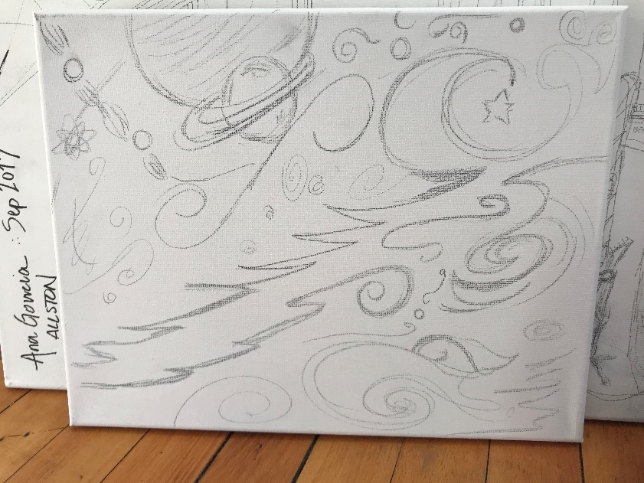

## Mixing colors - Always keep a good balance: black – colors – white;

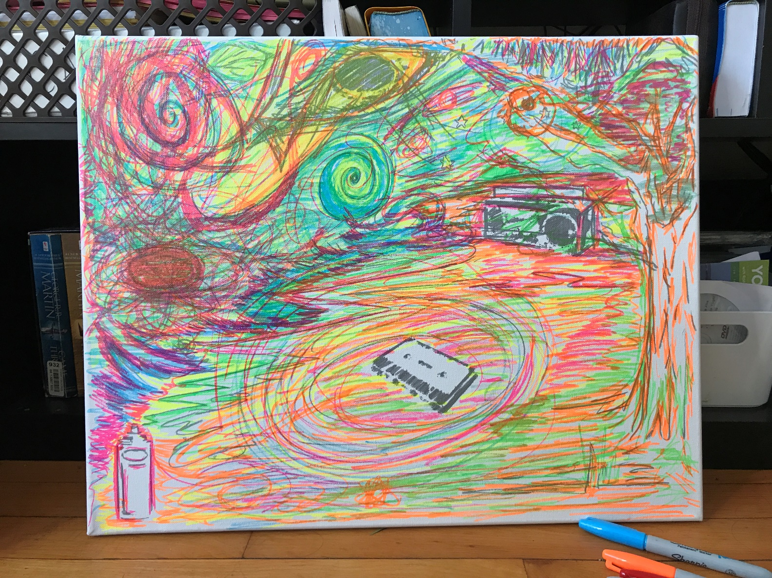

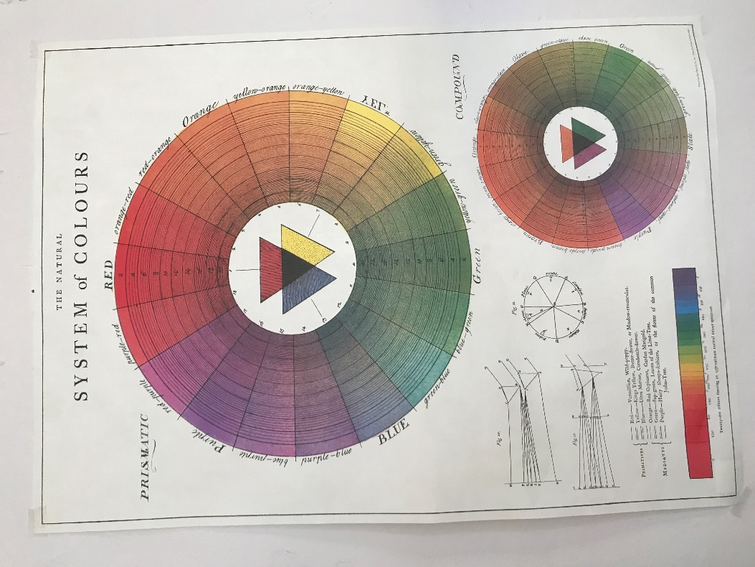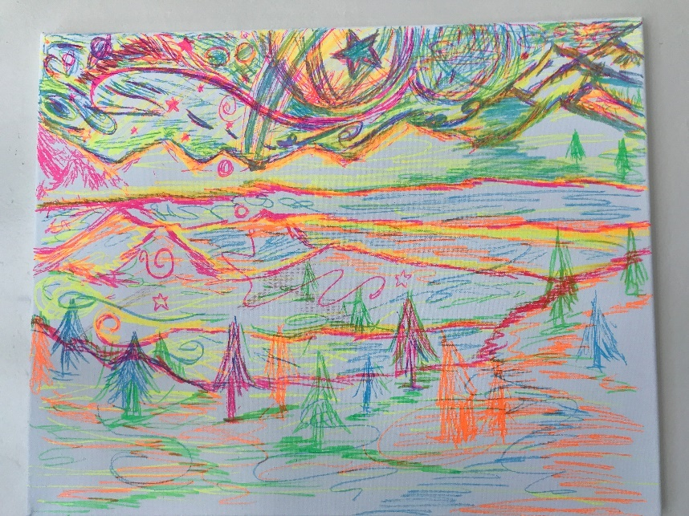

#### <Palette Idea>

## Transparency & Glows:

#### <Beach Detail>

See how the water glows over the sand… ever so slightly eventually creating shadow in some spots?

## Mists & Smokes:

#### <Chimney>

## Same as a chimney smoke, or water mist… it is somewhat of the same color, no?

## Fine line Details:

#### <Flowers in Field> <Fox Hair & Expressions>

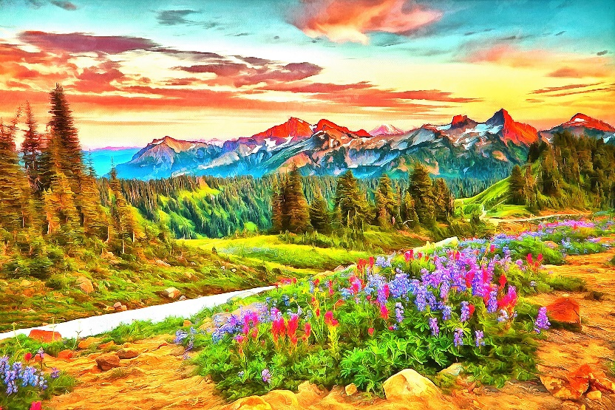

# Up Keep & Materials Maintenance:

## Once you have the following materials staged you are ready to start:

### Paint + Palette + Brushes + Containers w/ Solvents + Rags + Easel(canvas)

### <Amazon Oil Painting Material List> (http://www.amazon.com/hz/wishlist/ls/SUECQDK8X4YK)

Paint – Always use it minimally. A drop on the palette is a good start. Put the cap back on the tube, so it won’t ooze and dry out. You are allowed to measure out how much paint the content you are doing requires. Backgrounds generally require ________ paint.

### Palette – Wood vs. Plastic vs. Styrofoam: (A little math exercise)

|  |  |  |  |  |
| --- | --- | --- | --- | --- |
| **Qualities** | **Wood** | **Plastic** | **Styrofoam** | **ALT D** |
| **Price ($)** |  |  |  |  |
| **Vol (oz)** |  |  |  |  |
| **Mass (g)** |  |  |  |  |
| **Dims (ft or in)** |  |  |  |  |
| **Chemistry** |  |  |  |  |
| **Surface Area** | **Drier.** | **Oily** | **More oily.** |  |
| **RATIOS** |  |  |  |  |
| **$/VOL or $/mass** |  |  |  |  |
| **Effectiveness** |  |  |  |  |

Notes: _______________________________________________________________________________.

#### #RealWorldPOP

Skiing on metal rail vs. Skiing on wooden rail.

Metal had more friction, not sure if it had less ice built up in it than the wood, which then end up becoming smoother.

Your thoughts? ___________________________________________________________________________________.

Brushes – Like pencils these should be used to match the type of drawing done. Backgrounds may be easier done like a wall. So a wider bushier brush should do a good job. For most lines, a brush that is as comfortable as a pencil can allow the artist to gain more control over the instrument. The finer the brush tip, the more detailed the drawing will be.

In a way, a well-balanced paint should proceed from a wider and bigger brush defining background planes, to the first observable lines in a standard brush lines, to detail filling with the use of fine brushes.

#### <Brush Types w/ Dimensions>

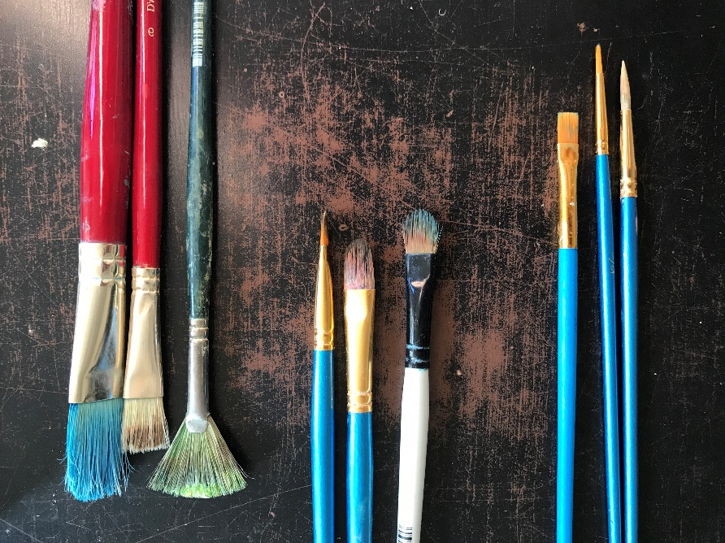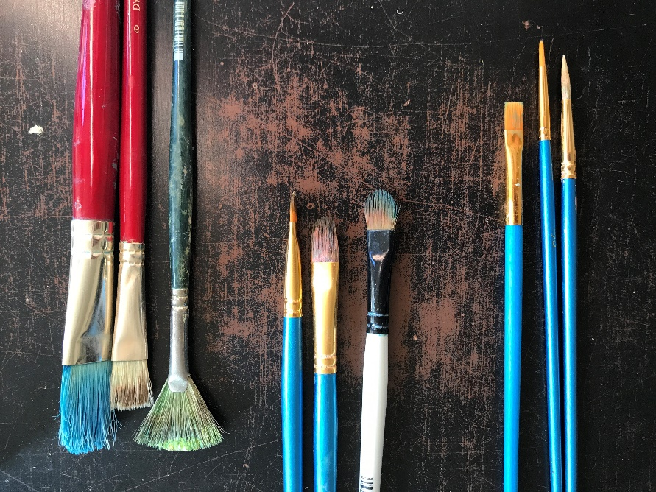

## Maintenance:

### So what do you think are best practices to keep your oil painting supplies longer? _______________________.

### Cleaning up the Palette + Brushes + Containers + Rags

## Chemistry of Oil Paint:

### <Where you can check this info: Google>

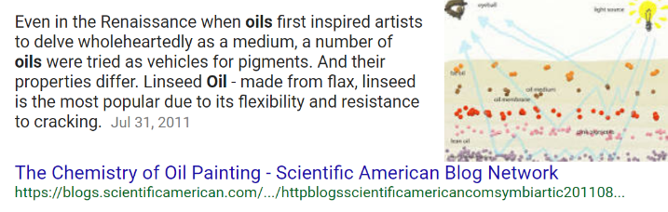Questions? _______________________________________________________________________________.

How long does it take for oil paint to dry? _______________________________________________________.

How did you measure that? __________________________________________________________________.

More on it: (https://blogs.scientificamerican.com/symbiartic/httpblogsscientificamericancomsymbiartic20110802the-chemistry-of-oil-painting/)

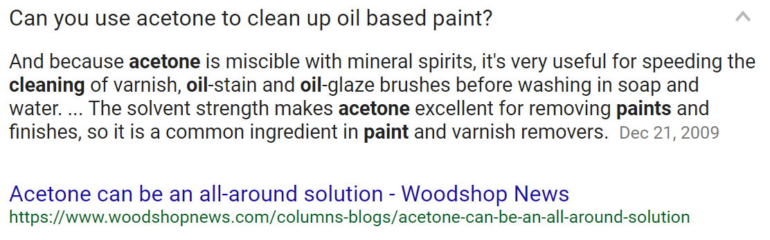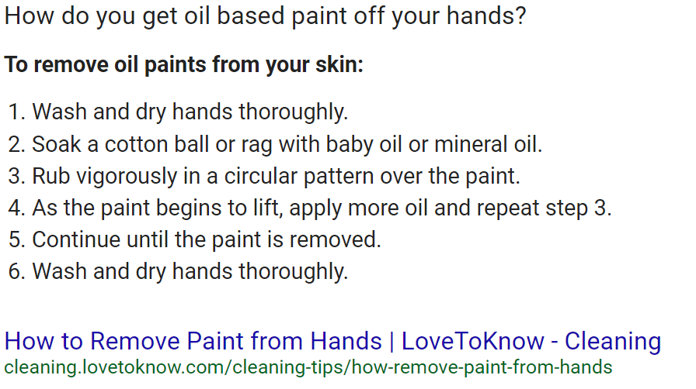

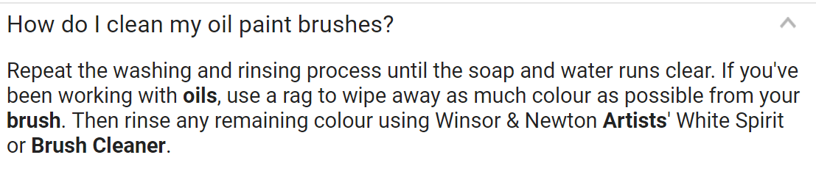

### Cleaning up materials chemistry:

|  |  |  |  |  |
| --- | --- | --- | --- | --- |
| **Qualities** | **ALT A** | **Turpenoid** | **Linseed Oil** | **ALT B** |
| **Price ($)** |  |  |  |  |
| **Vol (oz)** |  |  |  |  |
| **Mass (g)** |  |  |  |  |
| **Dims (ft or in)** |  |  |  |  |
| **Chemistry** |  |  |  |  |
| **RATIOS** |  |  |  |  |
| **$/VOL or $/mass** |  |  |  |  |
| **Effectiveness** |  |  |  |  |

Notes: _____________________________________________________________

___________________________________________________________________

___________________________________________________________________

___________________________________________________________________

# QUESTIONS:

## How do solvents and oil bond? _________________________________________________________.

## What mixture do you think will best clean up your brushes, palette & containers? _________________. Why would you think so? ______________________________________________________________.

## What kind of moods do the following paintings allow you to feel?